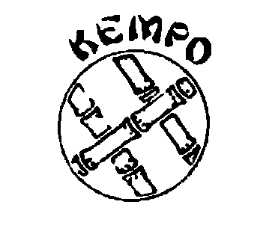
SAFEGUARDING CODE IN MARTIAL ARTS
SAFE PRACTICE POLICY
Wellingborough Kempo Karate Club
Martial Arts are activities where safe practice is essential to help prevent injury. Children* are particularly vulnerable as they are still developing mentally and physically, so training methods need to be modified as described below. (*also includes Adults at Risk)
Within the EKF coaching portfolios, particular reference is made to children and young people practicing together and this guidance in now included here. Martial Arts Instructors need to understand the added responsibilities of teaching children and also basic principles of growth and development through childhood to adolescence. Exercises should be appropriate to age and build. Instructors should not simply treat children as small adults, with small adult bodies.
• There is no minimum age for a child beginning Martial Arts, as the build and maturity of individuals varies so much. However the nature of the class must be tailored to consider these factors.
• In general, the younger the child, the shorter the attentions span. One hour is generally considered sufficient training time for the average 12 year old or below. Pre-adolescent children have a metabolism that is not naturally suited to generating anaerobic power, and therefore they exercise better aerobically, that is, at a steadily maintained rate. However, they can soon become conditioned to tolerate exercise in the short explosive bursts that more suit Karate training.
• Children should not do assisted stretching - they generally don’t need to, and there is a real risk of damage with an inconsiderate or over-enthusiastic partner.
• Children should be carefully matched for size and weight for sparring practice.
• Great care must be taken, especially where children train in the proximity of adults, to avoid collision injury.
• Children should not do certain conditioning exercises; especially those, which are heavy, load bearing, for example weight training or knuckle push-ups. Children should not do any heavy or impact work but should concentrate on the development of speed, mobility, skill and general fitness.
• No head contact is permitted for children participating in kumite or partner work due to significant, evidenced based health concerns surrounding the impacts of concussion.

